Day 4: Other Protocols in Action Theory
Q1. Install FileZilla Server on your Windows machine, create a user account, and set up a shared folder for FTP access.
Ans:
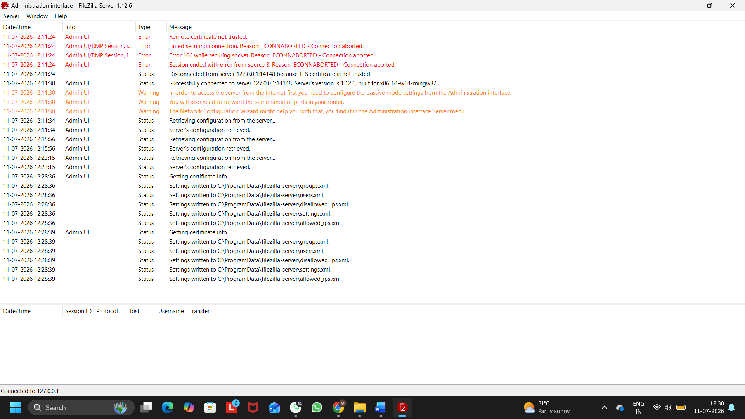
Figure 1: FTP User Created (User123)
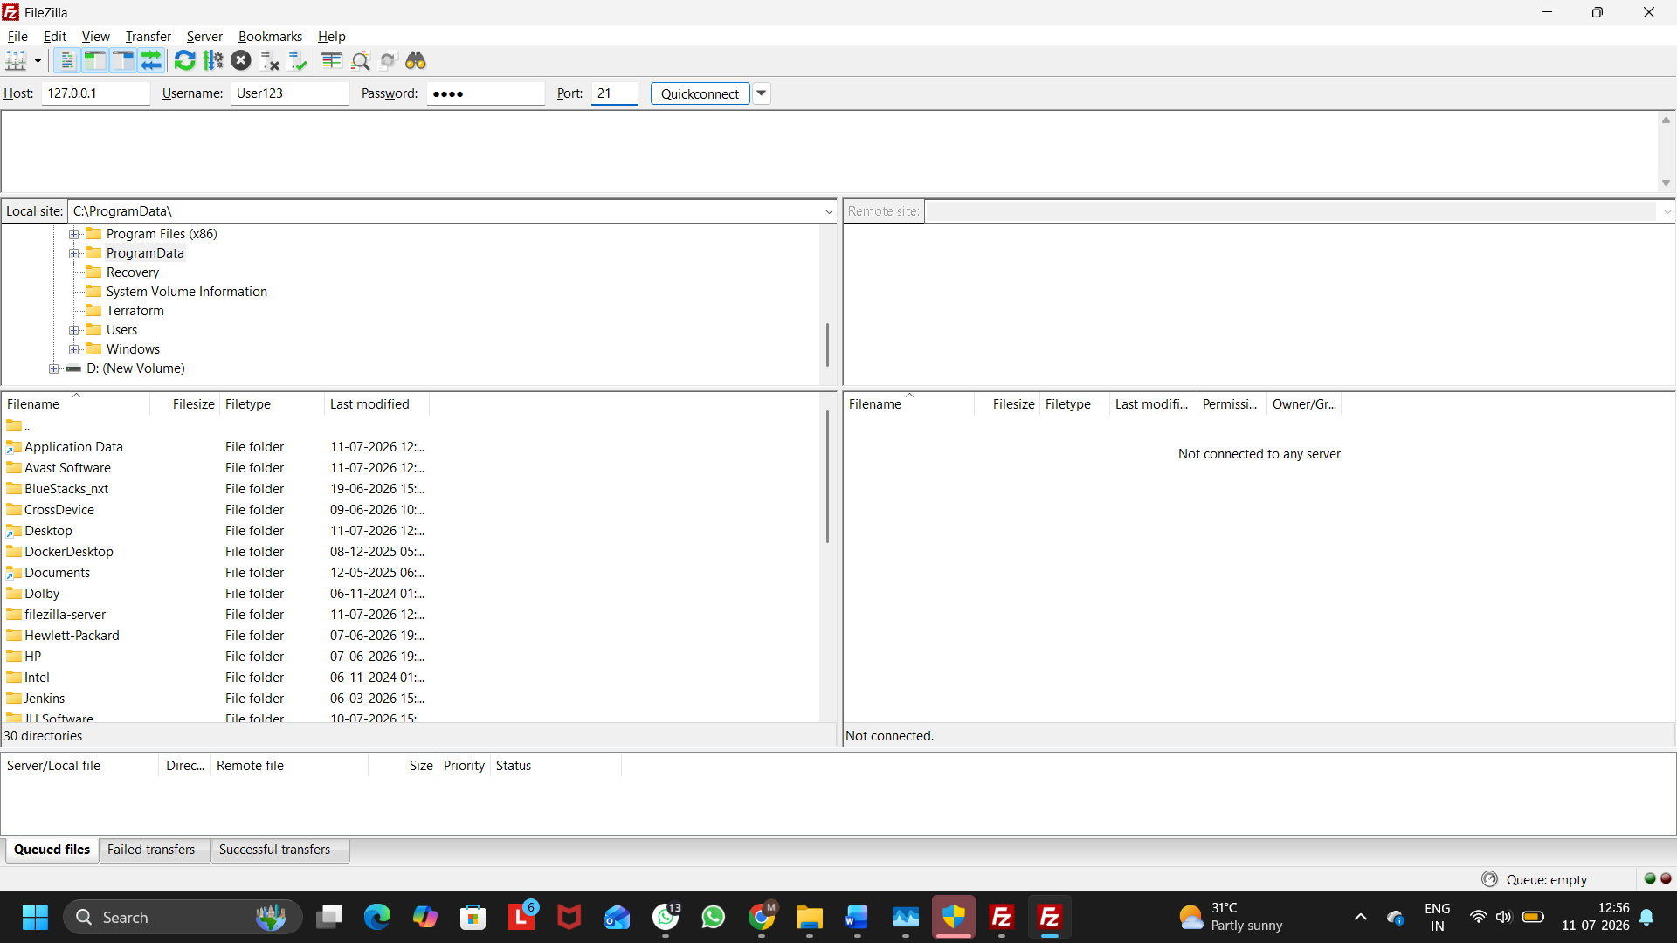
Figure 2: FTP Client Connection (127.0.0.1)
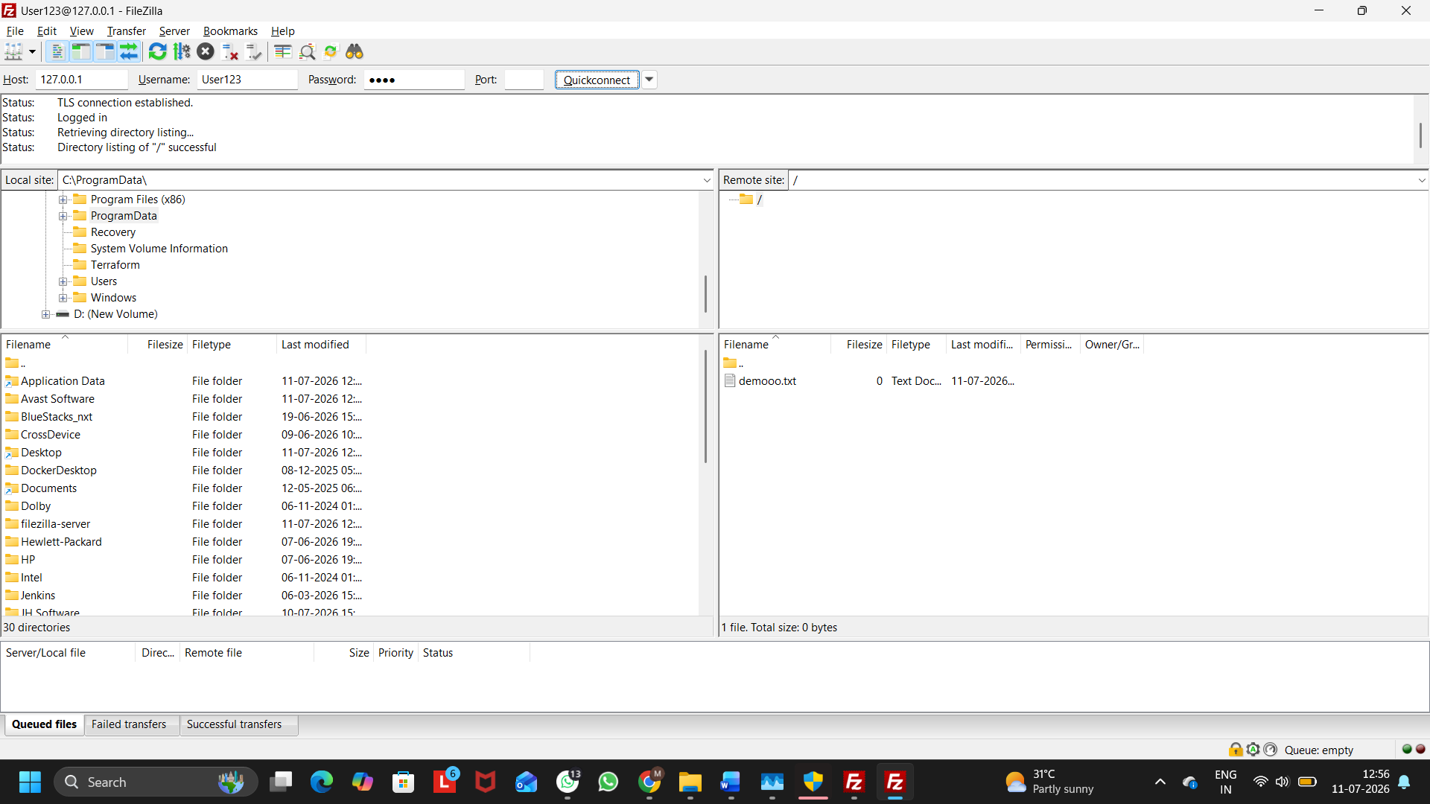
Figure 3: Successful FTP Login
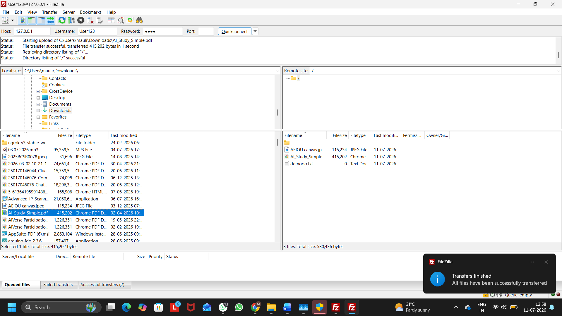
Figure 4: File Upload to FTP Server

Q2. Use FileZilla Client to connect to your FTP server using the credentials you created, and upload any image file from your computer to the shared folder.
Ans:
Uploading a File to the FTP Server Using FileZilla Client:
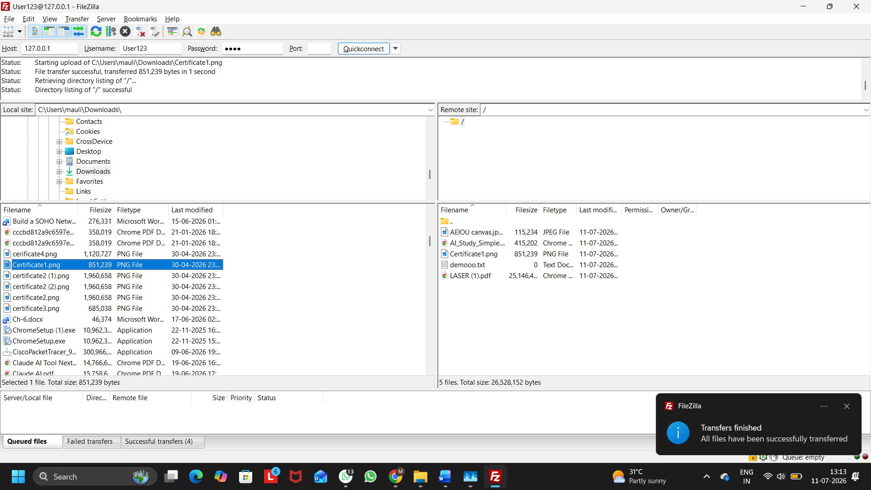
Figure 1: Dragging and Dropping the Certificate1 Image to the Shared Folder
- Opened FileZilla Client.
- Entered the FTP server details:
  - Host: 127.0.0.1
  - Port: 21
  - Username: User123
  - Password: 1009
- Clicked Quickconnect to connect to the FTP server.
- Selected the Certificate1 image file from the local computer.
- Dragged and dropped the Certificate1 image into the shared folder on the FTP server.
- Verified that the file was uploaded successfully and appeared in the remote FTP directory.

Q3. Download the uploaded file from your FTP server to a different folder on your computer using FileZilla Client, and verify the file size matches the original.
Ans:

Figure 1: uploaded file from your FTP server to a different folder

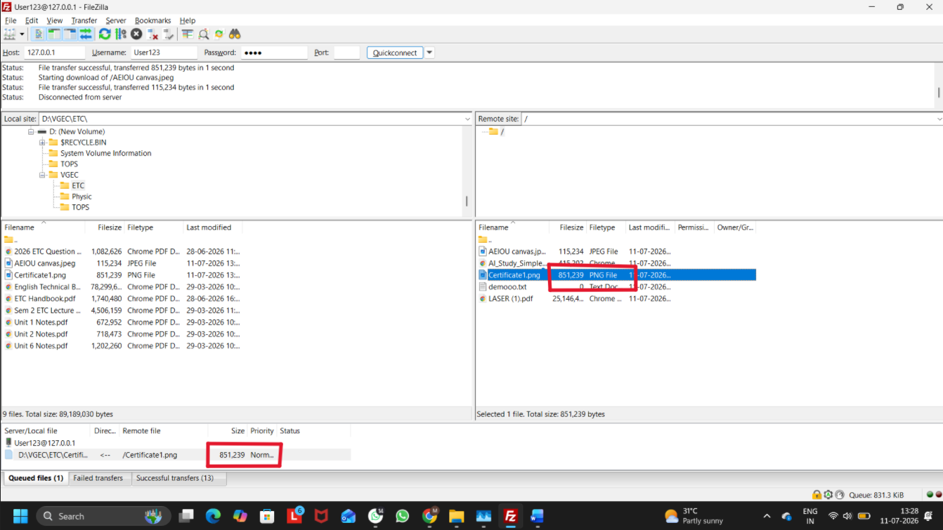
Figure 2: File Size Verification of the Original and Downloaded Files

The Certificate1 image was successfully downloaded from the FTP server to a different folder on the local computer. The file size of the downloaded image matched the original file, confirming that the file transfer was completed successfully without any data loss.
Q4. Research and list 3 real-world scenarios where SNMP is used in network management for apps or services you use (such as ISPs, campus WiFi, or large websites).<br><br><em><strong>Hint:</strong> Think about how network admins monitor device health, bandwidth, or uptime.</em>
Ans:
Real-World Applications of SNMP in Network Management:
Scenario | How SNMP is Used
1. Internet Service Providers (ISPs) | ISPs use SNMP to monitor routers, switches, bandwidth usage, and network uptime. This helps them quickly detect and resolve network issues.
2. Campus Wi-Fi Networks | Colleges and universities use SNMP to monitor Wi-Fi access points, connected users, signal strength, and device health to ensure reliable internet access across the campus.
3. Large Websites and Data Centers | Companies such as Google, Amazon, and Microsoft use SNMP to monitor servers, network devices, traffic, and system performance, ensuring their online services remain available and efficient.

Q5. Create a table comparing FTP and HTTP across at least 5 points: port number, security, data transfer method, use cases, and authentication.
Ans:
Feature | FTP (File Transfer Protocol) | HTTP (Hypertext Transfer Protocol)
Port Number | Uses Port 21 (Control) and Port 20 (Data) | Uses Port 80
Security | Not secure by default because data is transmitted in plain text. | Not secure by default. Secure version is HTTPS, which uses encryption.
Data Transfer Method | Used for uploading and downloading files between a client and a server. | Used for transferring web pages, images, videos, and other website content.
Use Cases | File sharing, website file management, and backups. | Browsing websites, accessing web applications, and viewing online content.
Authentication | Usually requires a username and password to access the server. | Generally does not require authentication for public websites, but login credentials may be needed for protected pages.

